“To Jump, or Not To Jump” Is Not the Question. Rather, *HOW* to Jump or Not to Jump That is the True Question

By: Gabriel Smith-Dalrymple

# Purpose:

The purpose of this document is the take a critical eye towards how tweaking one mechanic in a game can vastly change the experience of a game. To this end we will be looking at how a simple jump mechanic can change how the player completes a level. To examine the importance of this mechanic we will implement be implementing three types of jumping; basic jump, double jumping, and wall jumping. The additional mechanics of providing the player with a wall jump, and a double jump opens up the intended paths and lets players maneuver through the level in ways previously unattainable ways.

# Mechanics:

The mechanics used in this demo are purposely designed to be simple yet broad enough to cover most forms of movement that the player can use to get to the end goal. The types of movement that are implemented are:

* Running: Simple movement both left/right that flips the player’s sprite depending on the direction that the player is moving. This is the simplest form of movement that allows the player to get move around the level.
* Jumping: A basic form of jumping where when the *SPACE* bar is pressed and the character sprite is touching the foreground they jump into the air up to a specific height, and then they fall back down.
* Wall-Jumping: After executing a standard jump the player can press the directional arrow against a surface sticking the character there, once they’ve done that they can then jump again, allowing them to jump off the wall and gain access to areas a standard jump wouldn’t allow. This can be chained over and over to allow the player to climb a vertical object in the foreground.
* Double-Jumping: After jumping into the air the player is allowed to jump again at any time during their arc before they hit the ground.

# Importance to Game Design:

Movement is one of the most crucial aspects of any videogame. It is the cornerstone of one of the longest running franchise in videogame history, *Mario*. In exploring how a game chooses to implement a simple action like jumping we can infer many aspects about the game. If a game doesn’t allow the player to jump then we automatically know that vertical movement is only possible when using the environment to position us where we are allowed to go, whereas if the player is allowed to continuously jump forever then the character can theoretically go anywhere in the environment.

Obviously those two examples are extremes and shouldn’t be considered the “norm”, especially when there is an entire genre, “Platforming” that is dedicated to the movement abilities of the player and getting from one point to another. In looking at the spectrum between those two end-points we find a myriad of different types of movement mechanics that can be tested and explored.

# Knowledge Gained:

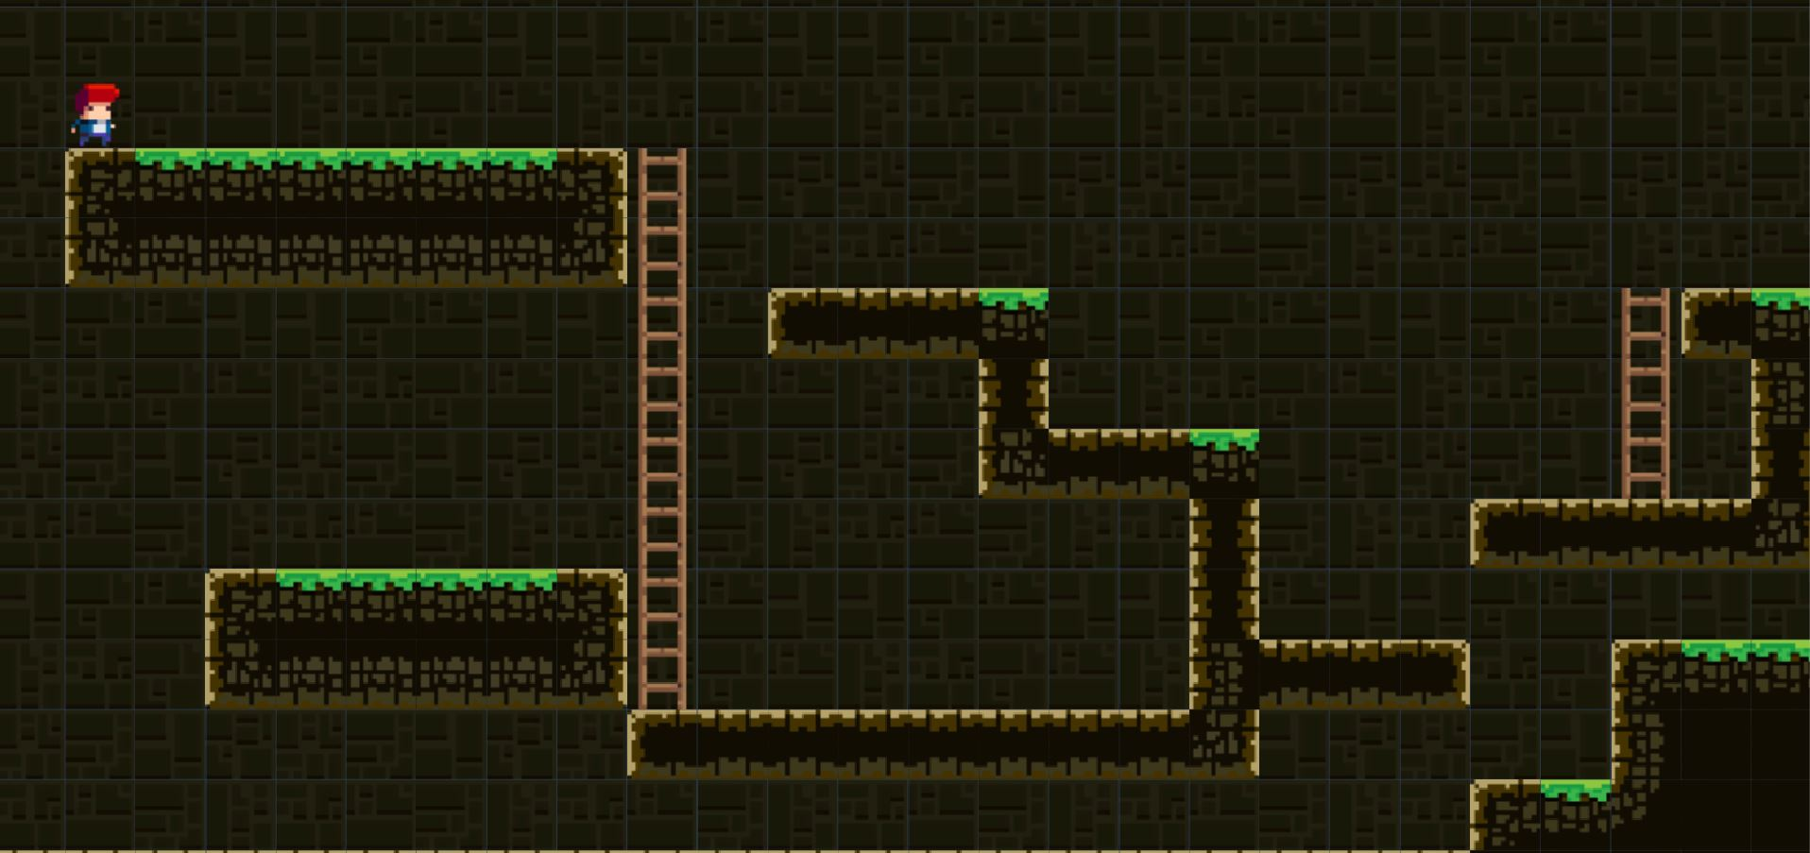The level above was designed based off of the videogame *Super Mario Bros*, specifically the level “World 1-2”. Having it be a level that contains both a floor and ceiling, it allows the player to experience multiple routes to complete the level as well as reach the secret exit.

Once the level was designed testing began with various versions of jumping being allowed to the player. The following sections detail the experiences that players had while trying to beat the level using various methods of jumping.

## No Jumping

This form was the most varied in responses. Some players enjoyed the challenge of not jumping, while others hated it. There were two consistent responses to this:

* Players were frustrated that they couldn’t access every part of the level
* Nobody wanted a full game like this, and only wanted it as a “challenge level”.

When asked about how they felt about this compared to games like *Captain Toad* who also can’t jump, players remarked that the *Captain Toad* game is more akin to a puzzle game, rather than a platformer like this one is.

## Normal-Jumping

Normal-jumping was really tepid in the response. Players were used to jumping, and once they understood how the jumping feels in this game they had no problem using it. This was expected as this was essentially the “control group” out of all the styles.

## Double-Jumping

This was fairly well received as it is a common platforming mechanic now, and is common in many videogames. The players didn’t really think that it did anything too special to change how they played the level, and mostly used the ability to more easily access the secret area instead of having to time their jumps like normal.

The primary response for this is that if the level was harder this would be a lot more fun. The lack of enemies reduced the stress factor of jumping, to the point that there wasn’t ever a fiero moment. The players wanted projectiles, and enemies that they needed to have to jump around.

## Wall-Jumping

Players found this approach to be interesting as it allows them the opportunity to move in a way that most games don’t utilize. They enjoyed the ability to navigate obstacles by climbing over them, rather than having to jump around. It was mentioned that this felt similar in design to the game *Celeste* which is one of the few 2D platformers that focuses on wall-jumping.

The most common comment on this style of movement is that it felt that it lends itself to more a vertical level design rather than horizontal. The player never really felt that the needed to wall-jump because there wasn’t ever anything they couldn’t get to without solid gameplay, wall-jumping just made it easier.

## Combined Wall and Double Jumping

This method of jumping was the best received overall as players felt that they were given the most ability to move around, but were still provided somewhat of a challenge based on their ability to climb walls and time jumps.

The primary complaint from players was that they never really felt “challenged” in the level and that having the ability to move around this much is overkill for the difficulty of the game they were presented.

## Free Jumping

This form was the easiest the beat the level and to allow the player to reach the secret exit. It elicited the most excited reactions at the beginning as players found it fun to just mash the jump button and watch their character fly off the screen. However, this excitement was short-lived as the novelty of the mechanic wore off rather quickly. Players seemed to find the ability to freely go wherever they wanted boring as it removed almost any and all challenge from the level. To give the player a sense of challenge two modes were tested, one with and one without a kill plane above the level.

### No Kill Plane

This was the easiest for the players to complete as they only had to worry about falling below the level to die, and provided they kept pressing the jump button it was near impossible to die unless they lost track of where they were off-screen and fell to their death when they stopped jumping so they would fall so fast that they couldn’t jump again and hit the kill plane below the level. This was also the least well received method, getting even worse remarks than the “No Jumping” mechanic.

### With Ceiling Kill Plane

This mode was received slightly better than the “No Kill Plane” as it didn’t fully let the players mash jump, and made it easier to keep track of their character since they couldn’t go too far above the level. With the threat of a kill plane most players would keep to double or triple jumps in rapid succession to gain a large amount of height quickly but were afraid of doing more because they didn’t want to die. When asked why they didn’t slowly but consistently jump to maintain a height they made references to games like *Flappy Bird* and pointed out that it’s basically flying but not in a fun way.

# Take Away

Jumping is such an incredibly important fundamental mechanic in modern games that just how it is implemented has a profound effect on the player’s experiences, and expectations. Given the ability to wall-jump players expect the level be more vertical, with only minor horizontal sections. Double-jumping is generally fun, but without a need to ever double-jump it feels wasted. Combining wall-jumping with double-jumping can be incredibly fun if the levels are designed to accommodate that, otherwise it feels like overkill and the player wonders why such complicated mechanics were implemented in such a base game.

It is with that in mind that when designers are deciding how they want their character to move that what they want the player to experience needs to be at the forefront of their minds, and jumping, or not jumping is a fantastic way to enable that experience.